**Interpolation with Equal Intervals**

Interpolation

▪ Interpolation is a process of computing intermediate values of an unknown function *f*(*x*) from a set of given values of that function.

▪ Let *y = f*(*x*) be a function of given by the values of *y0*, *y1*, *y2*, ..., *yn* which it takes for the values *x0*, *x1*, *x2*, ... *xn* of the independent variable *x.*

▪ If the given function *f*(*x*) is totally unknown or complicated, it is desirable to replace the given function by another which can be easily handled.

▪ Let φ(*x*) denotes an arbitrary simpler function so constructed that it takes the same values as *f*(*x*) for the values *x0*, *x1*, *x2*, ..., *xn*. ▪ Then if *f*(*x*) is replaced by φ(*x*) over a given interval, the process constitutes interpolation, and the function φ(*x*) is a formula of interpolation.

23 July 2021 MATH2231: Numerical Methods 2

Interpolation

▪ The φ*(x)* can take a variety of forms.

▪ When φ*(x)* is a polynomial, the process of representing *f(x)* by φ*(x)* is called parabolic or polynomial interpolation.

▪ When φ*(x)* is a finite trigonometric series, the process is trigonometric interpolation.

▪ Similarly φ*(x)* may be a series of exponential function, Legendre polynomials, Bessel function, etc.

▪ In practical problems we always choose for φ*(x)* the simplest function which will represent the given function over the interval in question.

23 July 2021 MATH2231: Numerical Methods 3

Interpolation: Justification

▪ The justification for replacing a given function by a polynomial rest on Weierstrass’s [1885] theorem stated below:

▪ Every function which is continuous in an interval (*a, b*) can be represented in that interval, to any desired degree of accuracy, by a polynomial.

▪ That is, it is possible to find a polynomial *P*(*x*) such that ⏐*f*(*x*) *- P*(*x*)⏐< ε for every value of *x* in the interval (*a, b*), where ε is the desired accuracy and ε > 0.

23 July 2021 MATH2231: Numerical Methods 4

Interpolation: Justification

▪ To justify the replacement of a given trigonometric function Weierstrass’s [1885] theorem states that:

▪ Every continuous trigonometric function of period 2π can be represented by a finite trigonometric series of the form *g*(*x*) = *a*0 + *a*1sin(*x*)+ *a*2sin(2*x*)+ … + *an*sin(*nx*) + *b*1cos(*x*) + *b*2cos(2*x*) + … + *bn*cos(*nx*)

▪ That is, it is possible to find a trigonometric function *g*(*x*) such that ⏐*f*(*x*) *- g*(*x*)⏐< ε for every value of *x* in the interval 2π where ε is the desired accuracy and ε > 0.

23 July 2021 MATH2231: Numerical Methods 5

Forward Difference

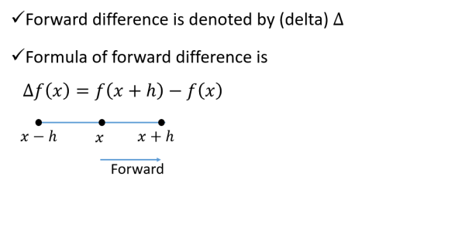23 July 2021 MATH2231: Numerical Methods 6

Forward Differences

▪ If *y0*, *y1*, *y2*, *...*, *yn* denote a set of values of any function *y = f*(*x*), then *y1- y0*, *y2- y1*, *y3- y2*, ..., *yn- yn-1*are called the differences of the function *y*.

▪ We denote these differences by Δ*y0*, Δ*y1*, Δ*y2*etc., where Δ*y0* = *y1- y0*, Δ*y1* = *y2- y1*, ..., Δ*yn-1* = *yn- yn-1*, Δ*yn*= *yn+1- yn*.

▪ Here, Δ is called the forward difference operator and Δ*y0*, Δ*y1*, Δ*y2,* ..., Δ*yn*are called first forward differences.

23 July 2021 MATH2231: Numerical Methods 7

Forward Differences

▪ The differences of these first forward differences are called second forward differences and are denoted by Δ2*y0 =* Δ*y1*- Δ*y0*, Δ2*y1=* Δ*y2-* Δ*y1*,etc.

▪ Similarly, one can define third forward differences, fourth forward differences, etc.

23 July 2021 MATH2231: Numerical Methods 8

Forward Differences

Thus,

2

Δ = Δ − Δ = − − − = − + *y y y y y y y y y y*

( ) 2

0 1 0 2 1 1 0 2 1 0

3

2

2

Δ = Δ − Δ = − + − − + *y y y y y y y y y*

0

*and* 4

1

3

2 ( 2 )

0 3 2 1 2 1 0 = − + −

*y y y y*

3 3 ,

3 2 1 0

3

Δ = Δ − Δ = − + − − − + − *y y y y y y y y y y y*

1

3 3 ( 3 3 )

1

0 4 3 2 1 3 2 1 0 = − + − +

*y y y y y*

4 6 4

4 3 2 1 0

23 July 2021 MATH2231: Numerical Methods 9

Forward (Diagonal) Difference Table ______________________________________________

*x y*

2 3 4 5 6 Δ Δ Δ Δ Δ Δ

_______________________________________________ *x y*

0 0

Δ

*y*

0

2

*x y y*

1 1

Δ

0

3

Δ Δ

*y y*

1

0

2

4

*x y y y*

2 2

Δ Δ

1

0

3

5

Δ Δ Δ *y y y*

2

2

1

4

0

6

*x y y y y*

3 3

Δ Δ Δ

2

3

1

5

0

Δ Δ Δ *y y y*

3

2

2

4

1

*x y y y*

4 4

Δ Δ

3

2

3

Δ Δ

*y y*

4

2

3

*x y y*

5 5

*x y* 6 6

Δ

*y*

Δ

5

4

23 July 2021 MATH2231: Numerical Methods 10

Class Work

Given the set of values

x 10 15 20 25 30 35 y 19.97 21.51 22.47 23.52 24.65 25.89 form the difference table and write down the values of

2

3

5

10 Δ*y* , Δ *y* , Δ *y and* Δ *y*

20

15

10

Δ = − = − =

*y y y*10 15 10

21.51 19.97 1.54

2

2

2

Δ = Δ − Δ = Δ − Δ − Δ − Δ *y y y y y y y*

20

( ) ( )

25

20 30 25 25 20

= Δ − Δ + Δ = − + = − *y y y*

2 24.65 2*23.52 21.51 0.08 30 25 20

23 July 2021 MATH2231: Numerical Methods 11

Class Work

Given the set of values, find the followings

2

3

5

10 Δ*y* , Δ *y* , Δ *y and* Δ *y*

20

15

10

**x y D y D^2 y D^3 y D^4 y D^5 y 10 19.97**

**1.54**

**15 21.51 -0.58**

**0.96 0.67**

**20 22.47 0.09 -0.68 1.05 -0.01 0.72**

**25 23.52 0.08 0.04 1.13 0.03**

**30 24.65 0.11**

**1.24**

**35 25.89**

23 July 2021 MATH2231: Numerical Methods 12

Backward (Horizontal) Differences 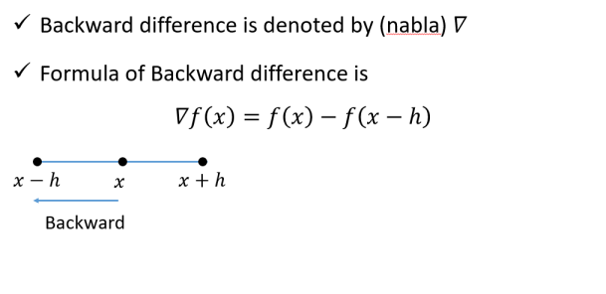23 July 2021 MATH2231: Numerical Methods 13

Backward (Horizontal) Differences

▪ The differences *y1- y0*, *y2- y1*, ..., *yn- yn-1*are called Backward or Horizontal Differences, if they are denoted by ∇*y1*, ∇*y2*, ..., ∇*yn*

▪ Here, ∇*y1* = *y1- y0*, ∇*y2= y2- y1*, ...∇*yn= yn- yn-1*,

▪ ∇ is called the backward difference operator.

▪ In a similar way, one can define backward differences of higher orders.

▪ Thus we obtain,

2

∇ = ∇ − ∇ = − − − = − +*y y y y y y y y y y*

( ) 2 ,

2 2 1 2 1 1 0 2 1 0

3

2

2

∇ = ∇ − ∇ = − + − *y y y y y y y etc*

3

3 3 ,

3

2 3 2 1 0

23 July 2021 MATH2231: Numerical Methods 14

Backward (Horizontal) Difference Table ________________________________________________________

*x y*

2 3 4 5 6 ∇ ∇ ∇ ∇ ∇ ∇

________________________________________________________ *x y*

0 0

*x y y*

∇

1 1 1

2

*x y y y*

∇ ∇

2 2 2

2

2

3

*x y y y y* ∇ ∇ ∇

3 3 3

3

3

2

3

4

*x y y y y y* ∇ ∇ ∇ ∇

4 4 4

4

4

4

2

3

4

5

*x y y y y y y* ∇ ∇ ∇ ∇ ∇

5 5 5

5

5

5

5

2

3

4

5

6

*x y y y y y y y* ∇ ∇ ∇ ∇ ∇ ∇

6 6 6

6

6

6

6

6

23 July 2021 MATH2231: Numerical Methods 15

Class Work

Given the set of values

x 10 15 20 25 30 35 y 19.97 21.51 22.47 23.52 24.65 25.89form the difference table and write down the values of

2

3

5

20 ∇*y* , ∇ *y* , ∇ *y and* ∇ *y*

25

30

35

23 July 2021 MATH2231: Numerical Methods 16

Class Work

Given the set of values, find the followings

2

3

5

10 ∇*y* , ∇ *y* , ∇ *y and* ∇ *y*

20

15

10

∇ ∇ ∇ ∇ ∇

**x y y 2 y 3 y 4 y 5 y**

10 19.97

15 21.51 1.54

20 22.47 0.96 -0.58

25 23.52 1.05 0.09 0.67

30 24.65 1.13 0.08 -0.01 -0.68 35 25.89 1.24 0.11 0.03 0.04 0.72

23 July 2021 MATH2231: Numerical Methods 17

Central Differences

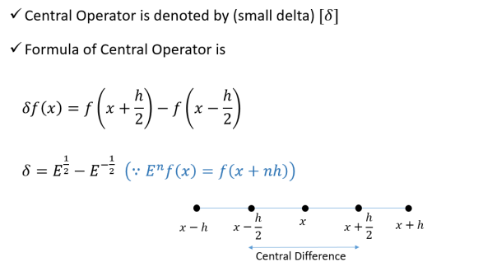23 July 2021 MATH2231: Numerical Methods 18

Central Differences and Central Difference Table

The central difference operator δ is defined by the relations *y y* δ*y y y* δ*y* ☹☹ *y y* δ*y*

1 0 1, , ,− −

− = − = − =

2 1 3

2

2

*n n n*

1 1

2

______________________________________________

*x y*

δ δ δ δ δ δ 2 3 4 5 6

_______________________________________________ *x y*

0 0

δ

*y*

1

2

*x y y*

2

1 1

δ

1

δ δ *y y* 3

3

2

3

2

*x y y y* δ δ

2

2 2

4

2

2

δ δ δ *y y y*

3

5

5

2

5

5

2

2

*x y y y y* δ δ δ

2

3 3

4

3

6

3

3

δ δ δ *y y y*

3

7

7

2

5

7

2

2

*x y y y* δ δ

2

4 4

4

4

4

δ δ *y y* 3

9

2

9

2

*x y y*

2

5 5

δ

δ

5

*y*

11

2

23 July 2021 MATH2231: Numerical Methods 19 *x y*

6 6

Class Work

Given the set of values

x 10 15 20 25 30 35 y 19.97 21.51 22.47 23.52 24.65 25.89form the difference table and write down the values of

2

3

5

10 δ*y* , δ *y* , δ *y and* δ *y*

20

15

10

23 July 2021 MATH2231: Numerical Methods 20

Relations in the Three Difference Table ▪ From the three tables we can see that

3

2

2

Δ = Δ − Δ = Δ − Δ − Δ − Δ*y y y y y y y*

2

3

Δ = −

( ) ( ) 2 4 3 3 2

*y y y* 0 1 0 ∇ = −

*y y y* 1 1 0

= Δ − Δ + Δ = − − − + − *y y y y y y y y y*

2 ( ) 2( ) ( ) 4 3 2 5 4 4 3 3 2 = − + −

*y y y y*

3 3

δ

21

= −

*y y*

1 0

5 4 3 2

3

2

2

∇ = ∇ −∇ = ∇ −∇ − ∇ −∇ *y y y y y y y*

5

( ) ( )

5

4 5 4 4 3

= ∇ − ∇ + ∇ = − − − + − *y y y y y y y y y*

2 ( ) 2( ) ( )

5 4 3 5 4 4 3 3 2 = − + −

*y y y y*

3 3

5 4 3 2

Δ = ∇ =

*y y*

δ

0 1 1 2

3

3

3

Δ = ∇ = *y y y*

2

5

δ

7

2

23 July 2021 MATH2231: Numerical Methods 21

Relations in the Three Difference Table Thus we obtain

*my y y* Δ = ∇ += δ +

*m*

*k*

*m*

*k m*

(2*k m*)

2

23 July 2021 MATH2231: Numerical Methods 22

Shift Operator

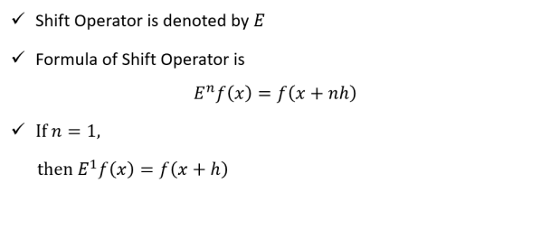23 July 2021 MATH2231: Numerical Methods 23

Average Operator

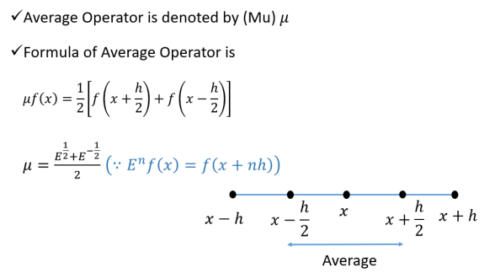23 July 2021 MATH2231: Numerical Methods 24

Differential Operator D

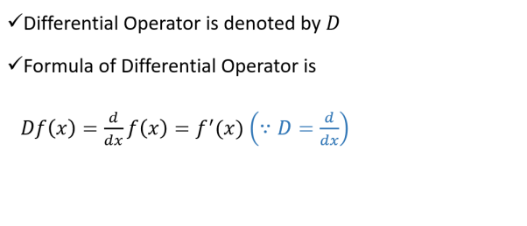23 July 2021 MATH2231: Numerical Methods 25

Relation between Operators( )



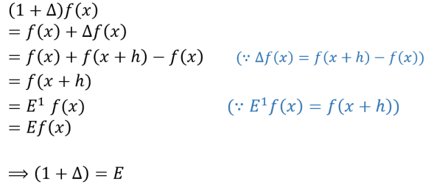23 July 2021 MATH2231: Numerical Methods 27



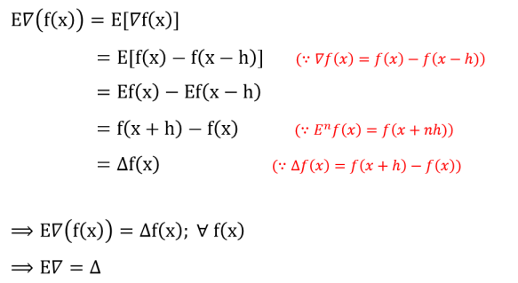23 July 2021 MATH2231: Numerical Methods 28



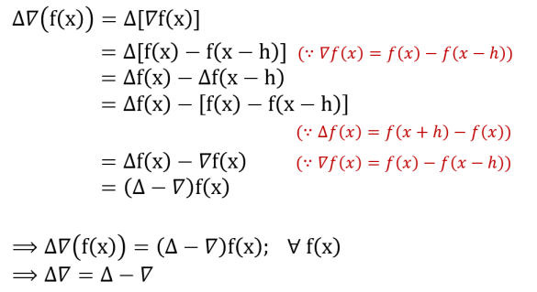23 July 2021 MATH2231: Numerical Methods 29



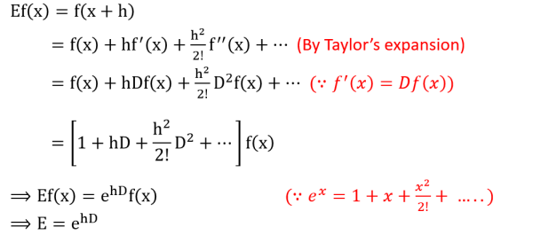23 July 2021 MATH2231: Numerical Methods 30

Effect of an Error in a Tabular Value

Let y0, y1, y2, ...yn be the true values of a function, and suppose the value y3to be effected with an error ε, so that its erroneous value is y3+ ε. Then the successive differences of the y’s

are as shown below:

______________________________________________

2 3

*y*

Δ Δ Δ

______________________________________________

*y*

0

Δ

*y*

0

2

*y y*

1

Δ

0

3

Δ Δ + *y y* ε

1

2

0

*y y*

2

Δ + 1

ε

3

Δ + Δ − *y y* ε ε

3

2

1

2

*y y* + Δ − ε ε

3

2

2

3

Δ − Δ + *y y* ε ε

3

2

2

3

*y y*

4

Δ + 3

ε

3

Δ Δ − *y y* ε

4

2

3

*y y*

*y*

5 6

Δ

*y*

5

Δ

4

23 July 2021 MATH2231: Numerical Methods 31

Cont.

Suppose that there is an error of +1 unit in a certain tabular value. As higher differences are formed, the error spreads out fanwise, and is at the same time, considerably magnified as shown below:

______________________________________________ 

*y* Δ Δ Δ Δ Δ

2 3 4 5

_______________________________________________

0

0

0 0

0 0

0 0 0

0 0 1

0 0 1

0 1 5

−

0 1 4

−

1 3 10

−

1 2 6

−

− −

1 3 10

0 1 4

−

0 1 5

−

0 0 1

0 0 1

−

0 0 0

0 0

0 0

23 July 2021 MATH2231: Numerical Methods 32 0

0

Cont.

The table shows the following characteristics:

•The effect of an error increases with the successive differences.

•The coefficients of the ε’s are the binomial coefficients with alternating signs.

•The algebraic sum of the errors in any difference column is zero.

•The maximum error in the differences is in the same horizontal line as the erroneous value.

The table in the next slide shows the effect of horizontal difference table:

23 July 2021 MATH2231: Numerical Methods 33

Cont.

______________________________________________ 2 3 4 5

*y* Δ Δ Δ Δ Δ _______________________________________________ 3010

3010

414

0

3424 -36

0

378 -39

3802 -75 178

-4 ε = 178

ε = -45 (approximate)

0 0 1

303 139 -449

0 0 1

4105 64 -271 367 -132 452

0 1 5

−

4472 -68 181 0 1 4

−

299 49 -227 4771 -19 -46

6 ε = -271

ε = -45 (approximate)

1 3 10

−

280 3 59 1 2 6

−

5051 -16 13 264 16 -13 − −

5315

1 3 10

0 1 4

−

Therefore, the actual entry is 4105 – ε = 4105 – (-45) = 41500 1 5

−

0 0 1

0 0 1

−

23 July 2021 MATH2231: Numerical Methods 34 0 0 0

**Pascal’s Triangle**

****23 July 2021 MATH2231: Numerical Methods 35

Effect of an Error in a Tabular Value of Backward Interpolation ________________________________________________________

*x y*

∇ ∇ ∇ ∇ 2 3 4

________________________________________________________ *x y*

0 0

*x y y*

∇

1 1 1

*x y y y*

▪ The effect of the error is the same as in the

∇ ∇

2

2 2 2

2

preceding table

*x y y y y* ∇ ∇ ∇

2

3 3 3

3

3

3

*x y y y y y* ∇ ∇ ∇ ∇

▪ But in this table the first

2

4 4 4

3

4

4

4

4

erroneous of any order is

*x y y y y y* + ∇ + ∇ + ∇ + ∇ + ε ε ε ε ε

in the same horizontal line

2

5 5 5

3

5

4

5

5

*x y y y y y* ∇ − ∇ − ∇ − ∇ −

ε ε ε ε

as the erroneous tabular

2 3 4 2

6 6 6

3

6

4

6

6

value.

*x y y y y y* ∇ ∇ + ∇ + ∇ +

ε ε ε

2

7 7 7

3

7

7

3 6

4

7

*x y y y y y* ∇ ∇ ∇ − ∇ −

ε ε

2

8 8 8

3

8

4

8

8

4

*x y y y y y* ∇ ∇ ∇ ∇ +

ε

2

9 9 9

3

9

4

9

9

*x y y y y y* ∇ ∇ ∇ ∇

2

10 10 10

3

10

4

10

10

23 July 2021 MATH2231: Numerical Methods 36

23 July 2021 MATH2231: Numerical Methods 37

Newton’s formula for Forward Interpolation

▪ Let *y* =*f*(*x*) denote a function which takes the values *y*0, *y*1, *y*2, ..., *yn*for the equidistant values *x*0*, x*1*, x*2*, ..., xn* of the independent variable *x*.

▪ It is required to find φ(*x*) , a polynomial of the *n-*th degree such that *y* and φ(*x*) agree at the tabulated points (i.e., they have the same values).

▪ Let φ(*x*) denote a polynomial of the *n-*th degree.

▪ This polynomial can be written in the form

φ *x a a x x a x x x x a x x x x x x* ( ) ( ) ( )( ) ( )( )( )

= + − + − − + − − − + 0 1 0 2 0 1 3 0 1 2 ...... ( )( )....( ) (1)

+ + − − − −

*a x x x x x x*

*n n*

0 1 1

23 July 2021 MATH2231: Numerical Methods 38

Newton’s formula for Forward Interpolation

▪ We shall now determine the coefficients *a*0, *a*1, *a*2, ..., *an*, so that we can get φ(*x*0) = *y*0, φ(*x*1) = *y*1, φ(*x*2) = *y*2, ..., φ(*xn*) = *yn*.

▪ We know that

φ *x a a x x a x x x x a x x x x x x* ( ) ( ) ( )( ) ( )( )( )

= + − + − − + − − − +

0 1 0 2 0 1 3 0 1 2

...... ( )( )....( ) (1)

+ + − − −

*a x x x x x x*

*n n*

0 1 1

−

▪ We can substitute the given successive values *x*0*, x*1*, x*2*, ..., xn*in equation (1).

▪ At the same time we can put φ(*x*0) *= y*0*,* φ(*x*1) *= y*1*,* φ(*x*2) *= y*2, ..., φ(*xn*)*=yn*.

▪ And let *x*1*- x*0 *= h*. Then, *x*2*- x*0 *= 2h*, etc, (since the values of *x* are equidistance).

23 July 2021 MATH2231: Numerical Methods 39

Newton’s formula for Forward Interpolation ▪ In equation (1) we have

φ *x a a x x a x x x x a x x x x x x* ( ) ( ) ( )( ) ( )( )( )

= + − + − − + − − − +

0 1 0 2 0 1 3 0 1 2

...... ( )( )....( ) (1)

+ + − − −

*a x x x x x x*

*n n*

0 1 1

−

▪ That is, at *x* = *x*0(substituting *x* with *x*0in equation (1)) we have φ *x a a x x a x x x x a x x x x x x* ( ) ( ) ( )( ) ...... ( )( )....( ) 0= 0+ 1 0− 0+ 2 0− 0 0− 1+ + *n* 0− 0 0− 1 0− *n*−1

*or*,φ(*x* ) = *a* = *y*

0 0 0

▪ Therefore we get, *a*0 = *y*0

▪ Similarly, substituting *x*1in the eq(1) we get

φ(*x*1) = *y*1= *a*0+ *a*1(*x*1− *x*0) = *y*0+ *a*1*h*

,Δ

*y y*

−

*y*

*or a*1 0 0

1

=

*h*

=

*h*

23 July 2021 MATH2231: Numerical Methods 40

Newton’s formula for Forward Interpolation

▪ Substituting *x*2in equation (1) we get, *y* = *a* + *a x* − *x* + *a x* − *x x* − *x*

( ) ( )( ) 2 0 1 2 0 2 2 0 2 1 *y y*

−

(2 ) (2 )( )

= +

*y* +

0*h a h h*

1 0

2

*h*

2

*y y y*

− +

*a*Δ

⇒ =

2

2 1 0

=

*y*

0

22 2

*h*

2

*h*

2

23 July 2021 MATH2231: Numerical Methods 41

Newton’s formula for Forward Interpolation ▪ Substituting *x*3in equation (1) we get,

*y* = *a* + *a x* − *x* + *a x* − *x x* − *x* + *a x* − *x x* − *x x* − *x* ( ) ( )( ) ( )( )( ) 3 0 1 3 0 2 3 0 3 1 3 3 0 3 1 3 2 *y y*

−

= +

*y y y* − +

2

*y* + (3 )2 3

*h*

+

0*h h a h h h*

1 0 2 1 0

(3 )(2 ) (3 )(2 )( )

*h*

2

*h*

3

*a*Δ

*y y y y*

− + −

⇒ =

3 3

3 2 1 0

=

*y*

0

36 3!

*h*

3

*h*

3

23 July 2021 MATH2231: Numerical Methods 42

Newton’s formula for Forward Interpolation ▪ Similarly,

4

*a*Δ

*y*

4*Class Work*

=

0

4!4 *h*

5

( )

6

*n*

Δ

*y*

Δ

*y*

Δ

*y*

*a*!

=

0

,

*a*

=

0

,...,

*a*

=

0

5

5!

*h*

5 6

6!

*h*

6

*nn h*

*n*

23 July 2021 MATH2231: Numerical Methods 43

Newton’s formula for Forward InterpolationSubstituting in equation (1) the values *a*0*, a*1*, a*2*,...an*, we have,

φ *x y*

Δ

*y*

0

2

Δ

*y*

0

3

Δ

*y*

0

( ) ( )

= + 0

*h*

*n*

*x x*

− + 0

2

*h*

( )( ) *x x x x*

− − + 2 0 1

3!

( )( )( ) *x x x x x x*

− − − + 3 0 1 2 *h*

......

+

Δ

*y*

0

( )( )....( ) (2) *x x x x x x*

− − −

0 1 1

*n h* !

*n n* −

▪ This is Newton’s formula for forward interpolation, written in term of *x*.

▪ This formula can be simplified by a change of variable.

23 July 2021 MATH2231: Numerical Methods 44

Newton’s formula for Forward InterpolationNow, we can rewrite eq(2) in the following equivalent form

φ

( ) ( *x y y*

*x x* −

2

Δ ⎛ − *y x x*

⎟⎠⎞

⎜⎝⎛ −

*x x*

⎞

= + Δ

0

)

+

0 0 1

⎟ +

0 0 *n*

1!

*h*

2!

⎜⎝

*h*

*h*

⎠

Δ ⎛ −

*y*

*x x*

⎟⎠⎞

⎜⎝⎛ −

*x x*

⎟⎠⎞

⎜⎝⎛ −

*x x*

⎟⎠⎞

......

.... (3)

+

0 0 1 1

*n*

!

⎜⎝

*h*

*h*

−

*h*

*n*

23 July 2021 MATH2231: Numerical Methods 45

Newton’s formula for Forward Interpolation ▪ Now, put the following in equation (3) *x x*= = +

− *h*

0,

*u or x x hu* 0

▪ Then, since *x*1 = *x*0 + *h*, *x*2 = *x*0 + 2*h*, etc. we have *x x h*

− +

*x x*

( )

*x x* −

−*u*

*h*

1 0 0− = −

▪ Similarly,

*h*

=

*h*

=

*h*

*h*

1

*x x* −

*x x h*

− +

( 2 ) 2 *x x*

−

*h*

=

=

2 0 0

− = − *u*

2,

*h*

*h*

*h*

*h*

.......................................................... *x x*

−

*x x n h*

− + −

[ ( 1) ] ( 1)

*x x*

−

*n h* −

−*u n*

*n*

=

=

−

= − +

1

1 0 0

*h*

*h*

*h*

*h*

23 July 2021 MATH2231: Numerical Methods 46

Newton’s formula for Forward Interpolation ▪ Substituting the values of (*x* – *x*0)/*h*, (*x* – *x*1)/*h* etc. in equation (3) φ = φ + =

( ) ( ) ( )

*x x hu g u*

0

*u u*

( 1)

−

= + Δ +

*y u y*

2

Δ + *y*

*u u u*

( 1)( 2) − −

3

Δ +

0 0

2!

0

3!

*y*

0

...

*u u u u u n* ( 1)( 2)( 3).......( 1)

− − − − +

*n*

+

*n*

!

Δ

*y*

0

(4)

▪ This is the form in which Newton’s formula for forward interpolation is usually written.

▪The reason for the name “forward” interpolation formula since the formula contains values of the tabulated function from *y0* onward to the right (forward from *y0*) and none to the left of this value.

▪ Because of this fact this formula is used mainly for interpolating the values of *y* near the beginning of a set of tabular values.

23 July 2021 MATH2231: Numerical Methods 47

Example 1

Find the cubic polynomial which takes the following values *y*(0) = 1, *y*(1) = 0, *y*(2) = 1 and *y*(3) = 10 Hence, or otherwise obtain *y*(0.5).

Solution.

*x y* Δ Δ2 Δ3

0 1

-1

1 0 2

1 6

2 1 8

9

3 10

23 July 2021 MATH2231: Numerical Methods 48

Example 1 Cont.

Here, *h* = 1, and

2

3

Δ

*y x y*

*y*

0

Δ

*y*

0

Δ

*y*

0

( ) ( )

= + 0

*h*

*n*

*x x*

− + 0

2

*h*

( )( ) *x x x x*

− − + 2 0 1

3!

( )( )( )

*x x x x x x*

− − − +

3 0 1 2

*h*

***x y*** Δ Δ**2** Δ**3**

......

+

Δ

*y*

0

( )( )....( ) *x x x x x x*

− − −

0 1 1

*n h* !

*n n* −

**0 1**

**-1**

= +*x x x x x x* ( 1)( 0)

− −

( 0)( 1) − −

( 0)( 1)( 2) − − −

**1 0 2**

1 2 3

1

+

2(1)

(2)

+

6(1)

(6)

**1 6**

=1− *x* + *x*(*x* −1)+ *x*(*x* −1)(*x* −2)

2 3 2

= − + − + − +

1 *x x x x* 3*x* 2*x* 3 2

= *x* − *x* +

2 1

**2 1 8 9**

**3 10**

23 July 2021 MATH2231: Numerical Methods 49

Example 1 Cont.

Therefore, the polynomial we obtained for the given tabular values is.

3 2

*y* = *x* − *x* +

2 1

Now,

*y*(0.5) = (0.5)3 – 2*(0.5)2 +1 = 0.625

(which is the same value as that obtained by substituting *x* = 0.5 in the cubic polynomial above.)

23 July 2021 MATH2231: Numerical Methods 50

Class Work

The table below gives the values of tan (*x*) for 0.10≤ *x* ≤0.30. Find tan(0.12)

*x* 0.10 0.15 0.20 0.25 0.30 *y* = tan *x* 0.1003 0.1511 0.2027 0.2553 0.3093

Answer is 0.120537

23 July 2021 MATH2231: Numerical Methods 51

Class Work

The population of a town is given below for a range of years. Estimate the population for the year 1895.

Year : *x* 1891 1901 1911 1921 1931

Population: *y* (in thousands)

46 66 81 93 101

*Answer: 54.85 Thousands*

23 July 2021 MATH2231: Numerical Methods 52

Newton’s formula for Backward Interpolation

▪ Let *y* =*f*(*x*) denote a function which takes the values *y*0, *y*1, *y*2, ..., *yn*for the equidistant values *x*0*, x*1*, x*2*, ..., xn* of the independent variable *x*.

▪ It is required to find φ(*x*) , a polynomial of the *n-*th degree such that *y* and φ(*x*) agree at the tabulated points (i.e., they have the same values).

▪ Let φ(*x*) denote a polynomial of the *n-*th degree.

▪ This polynomial can be written in the form

φ

( ) ( ) ( )( ) ( )( )( ) *x a a x x a x x x x a x x x x x x*

= + − + − − + − − − + 0 1 2 1 3 1 2

*n n n n n n*

− − −

...... ( )( )....( ) (1)

+ + − − −

*a x x x x x x*

*n n n* −

1 1

23 July 2021 MATH2231: Numerical Methods 53

Newton’s formula for Backward Interpolation

▪ We shall now determine the coefficients *a*0, *a*1, *a*2, ..., *an*, so that we can get φ(*xn*) = *yn*, φ(*xn-*1) = *yn-*1, φ(*xn-*2) = *yn-*2, ..., φ(*x*0) = *y*0.

▪ We know that

φ

( ) ( ) ( )( ) ( )( )( ) *x a a x x a x x x x a x x x x x x*

= + − + − − + − − − + 0 1 2 1 3 1 2

*n n n n n n*

− − −

...... ( )( )....( ) (1)

+ − − −

*a x x x x x x*

*n n n* −

1 1

▪ We can substitute the given successive values *xn, xn-*1*, xn*-2*, ..., x*0in equation (1).

▪ At the same time we can put φ(*xn*) *= yn,* φ(*xn*-1) *= yn*-1*,* φ(*xn*-2) *= yn*-2, ..., φ(*x*0)*=y*0.

▪ And let *xn*-1*- xn= -h*. Then, *xn*-2*- xn= -2h*, etc, (since the values of *x* are equidistance).

23 July 2021 MATH2231: Numerical Methods 54

Newton’s formula for Backward Interpolation

▪ In equation (1) we have

φ

( ) ( ) ( )( ) ( )( )( ) *x a a x x a x x x x a x x x x x x*

= + − + − − + − − − + 0 1 2 1 3 1 2

*n n n n n n*

− − −

...... ( )( )....( ) (1)

+ − − −

*a x x x x x x*

*n n n* −

1 1

▪ That is, at *x* = *xn*(substituting *x* with *xn*in equation (1)) we have *x a a x x a x x x x a x x x x x x* φ *n*= + *n*− *n*+ *n*− *n n*− *n*−+ + *n n*− *n n*− *n*− *n*−

( ) ( ) ( )( ) ...... ( )( )....( ) 0 1 2 1 1 1 *or*, (*x* ) *a y* φ = 0=

*n n*

▪ Therefore we get, *a*0 = *yn*

▪ Similarly,

*yn*−1= *a*0+ *a*1(*xn*−1− *xn*) = *yn*−*a*1*h or an n*∇ *n*

*y y*

,

−

=−1 1

*h*

=

*y h*

23 July 2021 MATH2231: Numerical Methods 55

Newton’s formula for Backward Interpolation

▪ Substituting *x*2in equation (1) we get,

*y a a x x a x x x x*

( ) ( )( ) *n*−2= 0+ 1 *n*−2− *n*+ 2 *n*−2− *n n*−2− *n*−1 *y y*

−

( 2 ) ( 2 )( )

= +−

*yn n*

*n*− + − −

1*h a h h*

2

*h*

2

*y y y*

− +

2

*an n n*∇ *n*

⇒ =− −1 2

=

*y*

22 2

*h*

2

*h*

2

23 July 2021 MATH2231: Numerical Methods 56

Newton’s formula for Backward Interpolation ▪ Substituting *xn*-3in equation (1) we get,

*y a a x x a x x x x* = + − + − −

( ) ( )( )

*n n n n n n n* − − − − −

3 0 1 3 2 3 3 1 ( )( )( )

+ − − −

*a x x x x x x*

3 3 3 1 3 2

*n n n n n n*

− − − − −

3

*a*∇ *n*

=

*y*

(Class Work)

33!*h*

▪ Similarly,

3

∇

4

*y*

∇

*n*

*y*

*a*!

4

=

*n*

4!6 *h*

,...,

*a*

*n*

=

*n h*

*n*

*n*

23 July 2021 MATH2231: Numerical Methods 57

Newton’s formula for Backward Interpolation Substituting in equation (1) the values *a*0*, a*1*, a*2*,...an*, we have,

φ

∇

*y*

*n*

∇

2

*y*

*n*

∇

3

*y*

*n*

( ) ( ) *x y*

= + *n*

*x x*

− + *n*

( )( ) *x x x x*

− − + 2 1

( )( )( ) *x x x x x x* − − − +

*n n*

− − − 3 1 2

*h*

∇

*n*

2

*y*

*h*

3!

*h*

*n n n*

......

+

*n*

( )( )....( ) (2) *x x x x x x*

− − −

*n h* !

*n n n* −

1 1

▪ This is Newton’s formula for backward interpolation, written in term of *x*.

▪ This formula can be simplified by a change of variable.

23 July 2021 MATH2231: Numerical Methods 58

Newton’s formula for Backward Interpolation Now, we can rewrite eq(2) in the following equivalent form

φ *n n*

*x x* −

2

∇ ⎛ − *y x x*

⎟⎠⎞

⎜⎝⎛ −

*x x*

⎟⎠⎞

( ) ( ) *x y y*

= + ∇

+

*n n n n* −

1

3

*h*

2

⎜⎝

*h*

*h*

+

∇ ⎛ − *y x x*

⎟⎠⎞

⎜⎝⎛ −

*x x*

⎟⎠⎞

⎜⎝⎛ −

*x x*

⎞

*n n n n* − −

⎟ +

3!

*n*

⎜⎝

*h*

*h*

1 2 *h*

⎠

∇ ⎛ −

*y*

*x x*

⎟⎠⎞

⎜⎝⎛ −

*x x*

⎟⎠⎞

⎜⎝⎛ −

*x x*

⎟⎠⎞

⎜⎝⎛ −

*x x*

⎟⎠⎞

⎜⎝⎛ −

*x x*

⎟⎠⎞

......

+

*n n n n n* − − −

.... (3)

1 2 3 1

⎜⎝

*n*

!

*h*

*h*

*h*

*h*

*h*

23 July 2021 MATH2231: Numerical Methods 59

Newton’s formula for Backward Interpolation ▪ Now, put the following in equation (3)

*x x*

−,

*n*= = +

*u or x x hu*

*h*

*n*

▪ Then, since *xn*-1 = *xn*- *h*, *xn*-2 = *xn*- 2*h*, etc. we have *x xn n n*

− −*u*

( ) 1+ = +

*x x h*

*h*

▪ Similarly,

− −

=

*h*

=

*x x*

−

*h*

*h h*

1

*x x*

− −

*x x h*

− −

( 2 ) 2 *x x*

=

=

−

*h*

+ = +

*u*

2,

*n n n*

2

*h*

*h*

*h*

*h*

.......................................................... *x x n h*

− − −

[ ( 1) ] ( 1)

*x x*

*x x* −

1

=

−

=

*n n*

+

*n h* −

= + − *u n*

1

*h*

*h*

*h*

*h*

23 July 2021 MATH2231: Numerical Methods 60

Newton’s formula for Backward Interpolation ▪ Substituting the values of (*x* – *xn*)/*h*, (*x* – *xn*-1)/*h* etc. in equation (3) φ = φ + =

( ) ( ) ( )

*x x hu g u*

*n*

*u u*

( 1)

+

= + ∇ +

*y u y*

*u u u*

( 1)( 2)

+ +

2 3 ∇ +

*y*

∇ + *y*

*n n n n*

2!

3!

*u u u u u n*

...

( 1)( 2)( 3)....( 1)

+ + + + −

*n*

+

∇

*y*

(2)

*n*

!

*n*

▪ This is the form in which Newton’s formula for backward interpolation is usually written.

▪ The reason for the name “backward” interpolation formula since the formula contains values of the tabulated function from *yn* onward to the left (backward from *yn*) and none to the right of this value.

▪ Because of this fact this formula is used mainly for interpolating the values of *y* near the end of a set of tabular values.

23 July 2021 MATH2231: Numerical Methods 61

Class Work

The table below gives the values of tan(*x*) for 0.10≤ *x* ≤0.30. Find tan (0.26)

*x* 0.10 0.15 0.20 0.25 0.30 *y* = tan *x* 0.1003 0.1511 0.2027 0.2553 0.3093

Answer is 0.265952

23 July 2021 MATH2231: Numerical Methods 62

Class Work

The population of a town is given below for a range of years. Estimate the population for the year 1925.

Year : *x* 1891 1901 1911 1921 1931

Population: *y* (in thousands)

46 66 81 93 101

*Answer: 98.837 Thousands*

23 July 2021 MATH2231: Numerical Methods 63

Extrapolation

▪ If the *n*th differences of a tabulated function are constant when the values of the independent variable are taken in arithmetic progression, the function is a polynomial of degree *n*.

▪ The process of finding the value of *y* for some value of *x* outside the given range is called extrapolation.

▪ If a tabulated value is a polynomial, then interpolation and extrapolation would give exact values.

▪ Newton’s forward difference formula is used to extrapolate values to the right of *yn*.

▪ Newton’s Backward difference formula is used to extrapolate values to the left of *y0*.

23 July 2021 MATH2231: Numerical Methods 64

Class Work

The table below gives the values of tan *x* for 0.10≤ *x* ≤0.30. Find tan (0.05) and tan (0.50)

*x* 0.10 0.15 0.20 0.25 0.30 *y* = tan *x* 0.1003 0.1511 0.2027 0.2553 0.3093

Solution tan (0.5) = 0.050048 and tan (5.0) =0.545836

23 July 2021 MATH2231: Numerical Methods 65

Example

The table below gives the values of *y* are consecutive terms of a series of which the number 21.6 is the 6*th* term.

Find the first and tenth terms of the series.

*x* 3 4 5 6 7 8 9

*y* 2.7 6.4 12.5 21.6 34.3 51.2 72.9

Solution

The difference table is shown in the next page

23 July 2021 MATH2231: Numerical Methods 66

Example

x y Δ Δ2 Δ3 Δ4

**3 2.7**

**3.7**

**4 6.4 2.4**

**6.1 0.6**

**5 12.5 3.0 0 9.1 0.6**

**6 21.6 3.6 0 12.7 0.6**

**7 34.3 4.2 0 16.9 0.6**

**8 51.2 4.8**

**21.7**

**9 72.9**

▪ From the difference table, it will be seen that the third differences are constant

▪ Hence, the tabulated function represents a polynomial of the third degree.

Solution

*y*(1) = 0.1

*y*(10) = 100

23 July 2021 MATH2231: Numerical Methods 67